**CNC**

**How the CNC Router works.**

The CNC router is a milling machine outfitted with motors that precisely control each axis (CNC stands for Computer Numerical Control). It is a subtractive process which uses a spinning bit to cut through material.The bits of the router can be switched out; we have a range of bits.

The machine has a 4′x4′ bed. We primarily cut wood (plywood as well as hard wood), fiberboard (MDF, masonite), plastic (acrylic, HDPE, LDPE, ABS), and foam (various densities). Material can be cut along two or three dimensions.

**2-Dimensional Milling**

The router follows vector lines. As with the laser cutter, these vector lines can be generated in Rhino. Since the bit has a diameter, you must specify how you want the machine to interpret your vectors. There are four options: **Inside, Outside, On The Vector, and Fill**.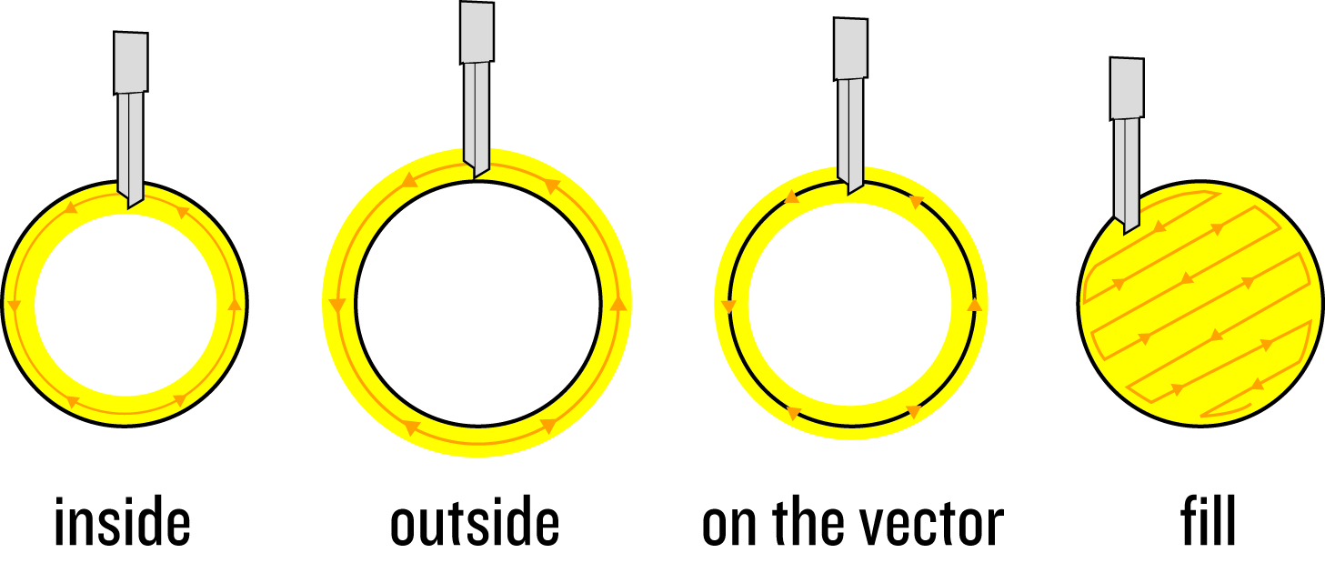

**Inside**: the edge of the bit will hit the edge of a closed shape from the inside.

**Outside**: the edge of the bit with hit the edge of a closed shape from the outside.

**On The Vector**: the center of the bit will follow the vector

**Fill**: the bit will completely remove the inside of a closed shape.

Since the machine has a Z-axis, you can specify how deep you want a path to be cut into the material. This is great for making dados or engraving graphics.

**3-Dimensional Milling**

The CNC router can also mill models from 3-dimensional files. For this to happen, the 3d file must be run through software that converts it into a set of instructions for cutting. It does this by analyzing the topology of the model and projecting a grid onto it. When cutting, the bit follows these gridlines (the distance between gridlines can be controlled, but is primarily based on the width of the bit). A basic diagram for the analysis of a 3d model along one axis:

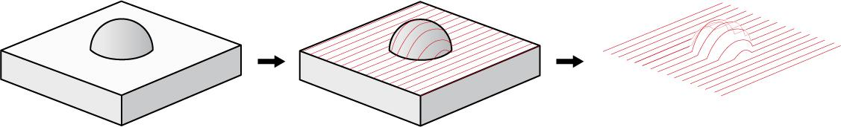

**A very important thing to note**: The bit is only capable of moving up and down; it doesn't rotate. This means that **undercuts are not possible**. Here is an illustration to clarify:



The CNC will be operated twice per week. Difficulty varies with the kind of file submitted. Expect a week turn-around time (or more depending on whether a studio is accessing it or not), not include file edits.

The bed of the CNC can handle up to 48" x 48" length (x-axis) and width (y-axis) And a height (z-axis) between 0" to 6" depending on type of profile and cutter needed.

_If you simply need "vector" parts cut out of sheet material (.3dm), you will need to email your file and set up a time to speak with a tech before processing.

_If you need a .stl file cut (a "3d" file) you will need to email your file and set up a time to speak with a tech before processing.

_Files should be in inches.

_You are responsible for the layout of your file; nesting parts and minimizing overall size will save you money.

(Offset tools in Rhino will help you visualize the path of the bit

when nesting parts. Use them.)The CNC will be operated twice per week. Difficulty varies with the kind of file submitted. Expect a week turn-around time (or more depending on whether a studio is accessing it or not), not include file edits.

The bed of the CNC can handle up to 48" x 48" length (x-axis) and width (y-axis) And a height (z-axis) between 0" to 6" depending on type of profile and cutter needed.

**File Preparation**

_No Duplicate Lines (Will extend cut time and prep time). Use Command SELDUP in Rhino to find duplicate lines within your file, use this command prior to joining shapes.

_Units: Inches.

_Draw workpiece boundary, recall that the final will have to come from a larger piece of material. Allow ¾” for the workpiece to be held to the cnc bed.

_Full Scale Model (The size you send it at is the size it will be cut at).

_Only Continuous Lines. The CNC will not cut where there is a gap in between to line segments. (No fragmented Lines: will extend file preparation on SHOP side and extend cut time. Costing more.) (Use Join Command to join shapes.

_Material + Thickness Specified. (Use Caliper to measure material thickness).

**Layer Setup**

Cut_DepthOfCut_CenterofLine/InsideOfLine/OutsideOfLine_SpecifiedCutterDim

i.e Cut_750_CenterOfLine_250_EndMill (125 = ⅛”, 250 = ¼”, 500 = ½”, 750 = ¾”, 1000 = 1”)

Drill_DepthOfDrill_SpecifiedCutterDim

Engrave_DepthOfEngrave_DegreeOfVBIT

e-mail us your file at --> iduarts.techroom@gmail.com